# EXERCISE 1

text = “goodMorning”

**Q1** – Execute these codes.

|  |  |
| --- | --- |
| **Code** | **Result** |
| text[2] | o |
| print( text[-2] ) | n |
| print( text[1:2] ) | o |
| print( text[:4] ) | goodM |

# EXERCISE 2

* Input text in the console
* Print index of the first letter “O”
  + If no O, write -1

**Q1** – What will be the **result** for these outputs?

|  |  |
| --- | --- |
| **Input** | **Output** |
| goodMorning | 1 |
| Hello | 4 |
| Rady | -1 |

**Q2** – Analyze **the symbols** you need to solve this problem.

|  |  |  |
| --- | --- | --- |
| Element | Do you need it? | For what? |
| Action | yes | For varivle |
| Decision |  |  |
| Repeat | yes | For loop |
| Input / Output | yes | For Input and putput |

**Q4**

* Propose **two different ways** to solve this problem

Way1

* n=input()
* sum=0
* i=0
* isO=True
* while isO and i<len(n):
* if n[i]=="o":
* sum+=i
* isO=False
* i+=1
* if sum>=0:
* print(sum)
* else:
* print("-1")

WAY2:

n=input()

sum=-1

for i in range(len(n)):

    if n[i]=="o":

        sum=i

if sum>=0:

    print(sum)

else:

    print("-1")

* Create two flowcharts

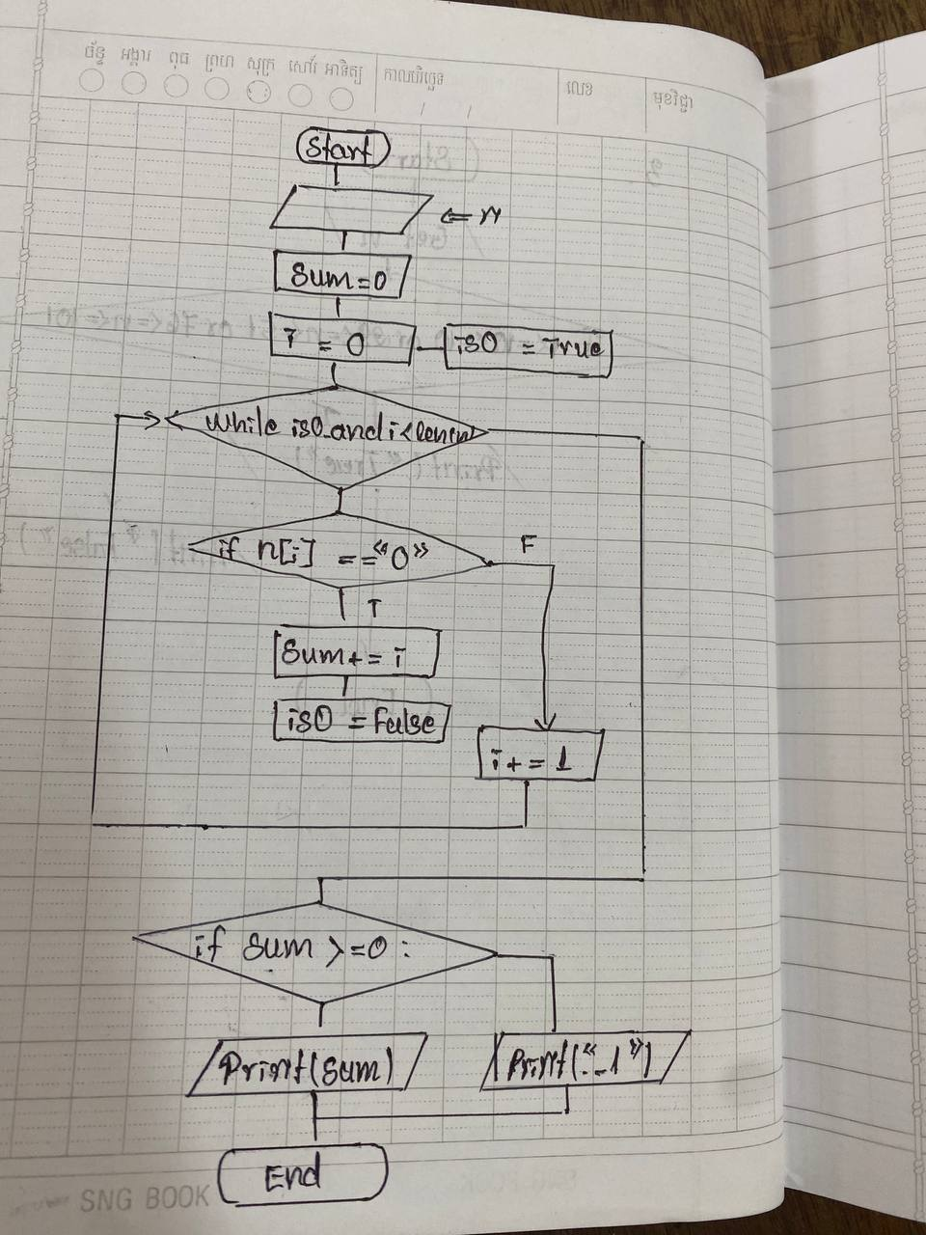 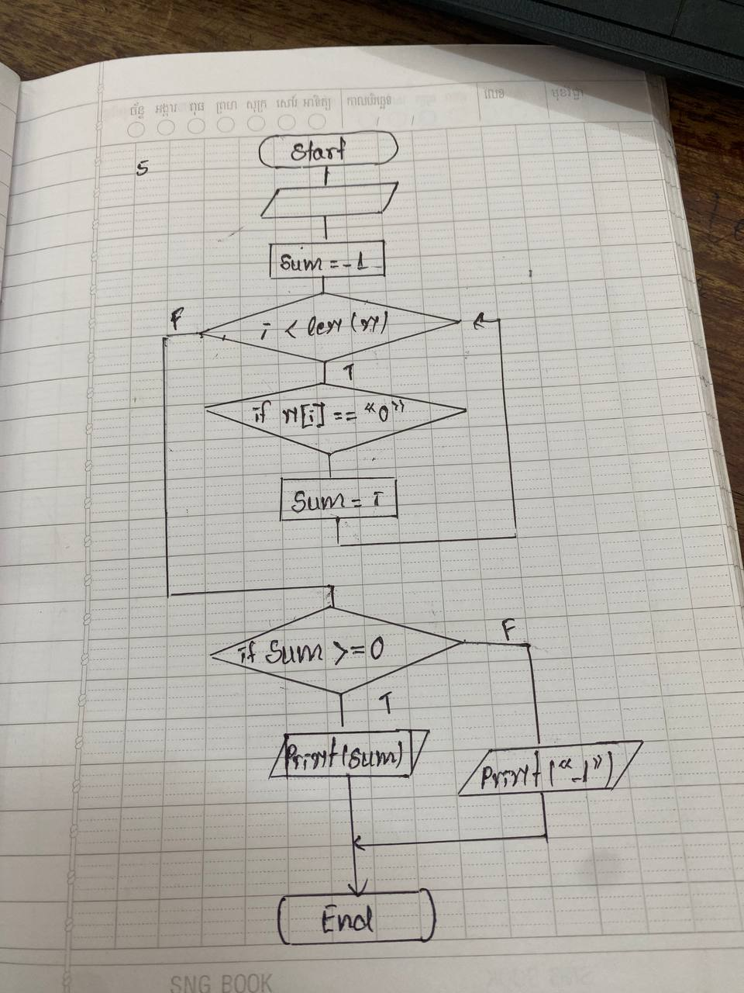

* Analyze what are the **advantages of each** of your solutions.

The anvantages of each of my solution are:

* Way1: I use while because it save time don’t need to check codition more when it met “o”.
* Way2: I use reoeat because it save space.

# EXERCICE 3

* Input two words in the console
* A number: the sum of uppercases in word1 + word2.

|  |  |  |
| --- | --- | --- |
| **Input** | **Output** | **Explanation** |
| aaBDcc  abcDE | 4 | *2 uppercases ("B" and "D") in word1 and 2 updaters (“D” and “E”) in word2* |
| aaZZD  SccDb | 5 | *3 uppercases ("Z" and "D") in word1 and 2 updaters (“S” and “D”) in word2* |
| azerty  qwerty | 0 |  |

**Q1** – What will be the **result** for these outputs?

|  |  |
| --- | --- |
| **Input** | **Output** |
| QZSd  sDFz | 5 |
| Asdcv  wxsdE | 2 |
| ASDX  wse | 4 |

**Q2** – Create a flowchart to solve this problem.

* For this question, you **cannot** **not** use the **repeat** block
* You can only use the 3 other blocs: Action, Decision, Input / Output

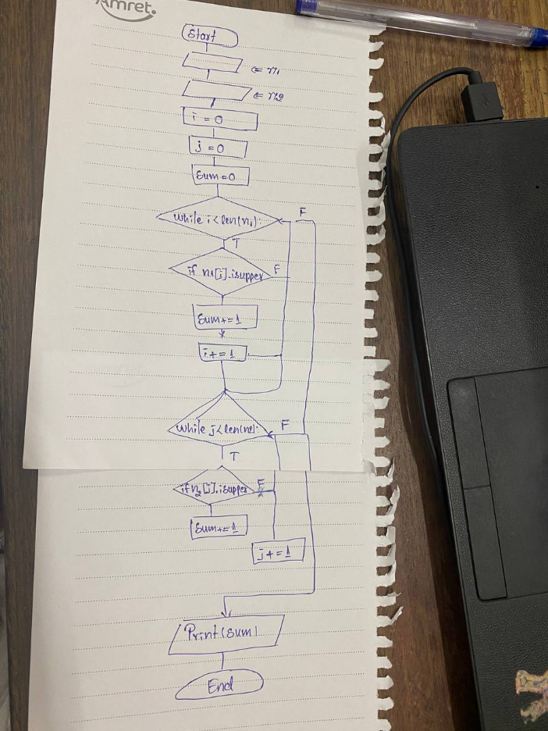

# EXERCISE 4

* Input text in the console
* Print index of the LAST letter “K”
* If no K, write -1

**Q1** – Complete the test cases.

|  |  |
| --- | --- |
| **Input** | **Output** |
| DDKDDDKE | 6 |
| DDKDDD | 2 |
| K | 0 |
| AA | -1 |
| xxKK | 3 |
| xKKK | 3 |
| KKKK | 3 |

**Q2** – What is the bug on this code?

text = input()

result = -1

is_finished = False

for index in range(len(text)) :

Error on this

    letter = text[index]

    if letter == "K" and is_finished:

        result = index

        is_finished = True

print(result)

**Q4** – To find the bug, test this code and check if the output is correct.

|  |  |
| --- | --- |
| **INPUT** | **OUTPUT** |
| KK | 1 |
| KKK | 2 |

**Q4** – Correct the code from question 2 to fix the bug.

text = input()

result = -1

is_finished = True

for index in range(len(text)) :

    letter = text[index]

    if letter == "K" and is _finished:

        result = index

        is_finished = False

print(result)